ePortfolio
Section 1: What is Full Stack Development?

CET138 Full Stack Development | Assignment 1
What is Full Stack Development?
Full stack development refers to the approach of developing an entire web application, handling all its layers, from the user interface to the application logic on the server, to the data stores on the database. The CodeCraft website itself is a real-world application: it is an HTML/CSS/Styled Front End with a back-end server and data layer built in JavaScript.
The word 'stack' is used to describe the technology stack that is layered over to create the working application. A ‘full stack’ developer will be at ease working with any of them.

2. The Three Layers — Demonstrated in CodeCraft
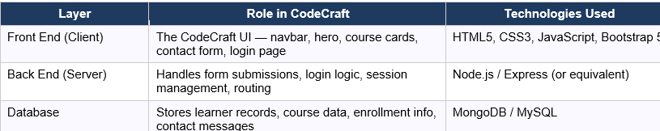

When a learner submits the CodeCraft contact form, the following full stack cycle runs: the front-end JavaScript captures the form values and sends an HTTP POST request to the server; the back end validates the data and writes it to the database; the server responds with a success message; JavaScript displays the toast notification ('Message sent successfully!').

3. CodeCraft as a Full Stack Application

3.1 Front-End Features (this project)

3.1 Front-End Features
- codecraft.html – Single-page website with Home, About, Portfolio, Contact, and Login sections.
- SPA navigation using showPage() in main.js without page reloads.
- Animated hero section with background effects, particles, and floating cards.
- Course grid, testimonial slider, and animated statistics counters.
- Contact form with client-side validation and toast messages.
- Login/Register switcher built with JavaScript.
- Demo viewer that displays HTML, CSS, JavaScript, and Bootstrap examples in a modal.
3.2 Full-Stack Concepts Demonstrated
- HTTP Request–Response: The contact form could send data to a server endpoint such as /api/contact.
- Client-Side Routing: showPage() demonstrates basic SPA navigation concepts.
- DOM State Management: The app tracks and updates the active page and navigation links.
- Separation of Concerns: HTML for structure, CSS for styling, and JavaScript for functionality.

